Version 1.0 final

Team assignment 1 – Architecture the drivers.

- High level functionality.
ID | Name | Description
F01 | Customer management | Support user to add, edit or disable customer informantion. Calculate and store customer’s bonus point.
F02 | Sale management | Support user to make a payment, export and print invoicesto customer.
F03 | Product management | Support user to manage product, product categories, product quantity.
F04 | Price management | Support user to manage commodity price include standard price and retail price.
F05 | Synchronization | Support to sync data between clients and server.
F06 | Statistics and reports | Support to make statistics and reports in real time.
F07 | Shop management | Manage goods, group of goods and price in local shop.
F08 | User management | Manage cashier information in system

- Constraints.
Technical constraints.

ID | Name | Description
 | System | Both the head office server Database and the POS terminal Database can be accessed during the sales operation
 | System | The product codes can read with bar code readers of POS terminals or enter code by ussing computer keyboard
 | Network | Client – server, POS client and center server
 | Database | SQL server
 | Database | Server and client use local database for system.

Bussines constraints
ID | Name | Description
1 | The bonus point rate | is fixed, and stored in the system as constant
2 | Point are recorded in the system, and not on card | The awarded points can be used by the member who accrued the points in place of cash when making a purchase. Points can be used in all stores.
3 | The bonus points become valid for use the following day
4 | The number of points used is immediately subtracted from the number of points accrued by the member
5 | For each product, its standard price, common to all stores
6 | The system executes a batch process which post-processes the sales operations from previous day, and prepares for the daily sales operations.
7 | Develop within 6 weeks. | Constraint about schedule of project.
8 | Develop team just have 5 members. Lack of skills. | Constraint about team abliity

- Quality attribute.
ID | Quality Attribute
QA.01 | Performance
QA.02 | Availability
QA.03 | Usability
QA.04 | Security

Availability Scenario. The system provides failover when incidents occur.
Portion of scenario | Possible value
Soure | Internal
Stimulate | System failure
Artifact | System, server – POS clients
Environment | System operating environment (runtime)
Response | Use local database anywhen to protect system against cracking.
Response measure | No down time.

Perfomance Scenario. The system execute transaction immediately
Portion of scenario | Possible value
Soure | Administrators.
Stimulate | synchronization
Artifact | server – POS clients
Environment | System operating environment (runtime)
Response | Moreover, in addition to the sales operation, the system is also capable of performing the statistical analysis on the sales records of all stores in near real-time manner.
Response measure | Synchronized within 60s after each 1 hour.
Portion of scenario | Possible value
Soure | Cashiers – administrators
Stimulate | Initiate transactions
Artifact | POS clients
Environment | System operating environment (runtime) – normal mode
Response | When the points are used, the number of points used is immediately subtracted from the number of points accrued by the member.  Member point will be stored in local database.
Response measure | Average latency immediately (within 5s)
- Process.
Time to develop this project is 6 week, finish when the end of course. Team resource is 5 member, still lacking in some skills, analysis, design and programming. Requirements are ambiguous, customers request not clear.
Team have experience in traditional, water fall model. Requirements are ambiguous and ability of each person is different, so team will choose water fall model (traditional metholology) has been modified to apply for project. But duration to develop product too short, team will only choose some feature to develop, not all.
- Organizations.

Member | Role | responsibility
Van Le Thi Bich | Team leader | Manage team and project, collect member effort log, assign works, control status of progress.  Planning and review document.
Tam Do Minh | Member and recorder | Record meeting minutes. Prepare templates and documents.  Analysis requirements and design system. Programming, review and testing as other standard member in team.
Huyen Le Dinh Thach | Member | Standard member.  Do assigned work. Participate in review and test phase.
Tin Nguyen Trung | Member | Standard member.  Responsible in testing. Do assigned work.
Son Dang Huy | Member | Analysis requirements and design system.

- Strongs.
- Each person has a high professional specific ability.
- Have experience in water fall model.
- Have good communicate with each other.
- Have many support from customers.
- Good management tool
- Weaks.
- Lack in many skills.
- Analytical ability and programming is limited.
- Efforts of members is still low.
With above requirement and time, we only can develop some following feature operate on shop system only.
Sale management. Customer management. Commodity management. Synchronization and price management.
Use case diagram.

Actor | Description
Admin | Admin has responsible in manage shop, goods in shop and price of them.
Cashier | Cashiers will have responsible to calculate goods price, customer’s score
Timer | System component. Auto record transactions in payment progress and auto sync between client and server.

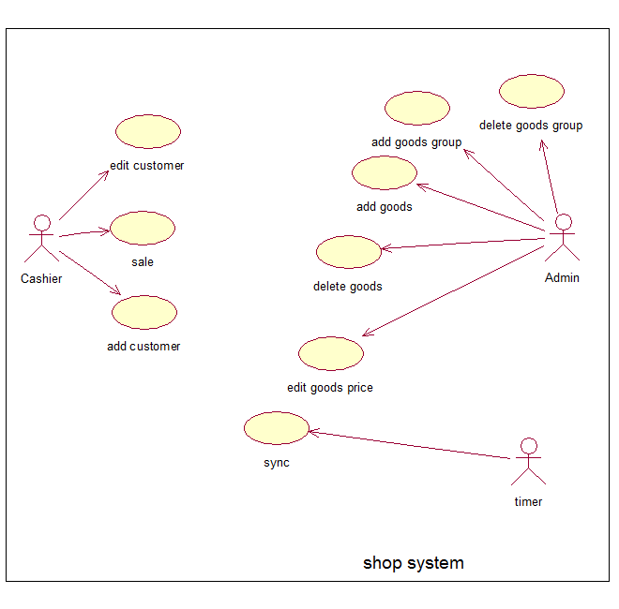

Usecase table.
Usecase ID | Name
UC01 | Add customer
UC02 | Edit customer
UC03 | Sale
UC04 | Add goods
UC05 | Edit goods price
UC06 | Delete goods
UC07 | Add goods group
UC08 | delete goods group
UC09 | Sync

Use-Case ID:UC01 | Use-Case Name: add customer
Actor: cashier
Description: | Support actor to add customer information in system.
Preconditions: | Customer ID is not exist in system.
Primary Pathway: | - Actor click “create new customer” button.  - Actor fill customer information in form.  - Click “ok”.  - Program will check information.  - Sent new customer to server.  - Shop server check new customer information.  - Store into shop server database and send to main server.  - Main server sync new information between the others shop server.
Alternative Pathways: | - Check in database and see this customer ID is already exist, return to main screen and show message “ID is already exist, can not create new customer”.
Exception Pathways:
Includes
Extends | None

Use-Case ID:UC02 | Use-Case Name: Edit customer
Actor: cashier
Description: | Support actor to edit customer information in system.
Preconditions: | Customer ID already exist in system.
Primary Pathway: | - Choose customer that actor want to edit.  - Click “edit” button.  - Edit information show on form.  - Click save.  - Program check input information.  - Program send new information to shop server.  - Shop server will check and send to main server.  - Main server will sync new information between the others shop server.
Alternative Pathways: | - Program check information, if invalid, do not send new information to shop server and show message “ invalid input”.
Exception Pathways:
Includes
Extends | None

Use-Case ID:UC03 | Use-Case Name: Sale
Actor: cashier
Description: | Help actor calculate money customer must pay and calculate customer score.
Preconditions:
Primary Pathway: | - Type the bar code or use barcode reader to input barcode into computer.  - After scan all goods, click “finish”.  - System will calculate money and show total that customer must pay on screen.
Alternative Pathways: | - If customer has member card, system calculate customer score and add to customer account.
Exception Pathways:
Includes
Extends | None

Use-Case ID:UC04 | Use-Case Name: add goods
Actor: admin
Description: | Support actor to add new goods information in system.
Preconditions: | Goods is not exist in system.
Primary Pathway: | - Actor click “create new goods” button.  - Actor select what ever he want in list to his shop.  - Click “ok.  - Shop server check new goods in system.  - Store into shop server database.
Alternative Pathways: | - Check in database and see if new goods is already exist, return to main screen and show message “already exist, can not create new goods”.
Exception Pathways:
Includes
Extends | None

Use-Case ID:UC05 | Use-Case Name: edit goods price
Actor: admin
Description: | Support actor to edit goods price in system.
Preconditions: | Goods is exist in shop system.
Primary Pathway: | - Actor choose a goods.  - Click “edit price” button.  - Change price of goods.  - Select time to apply change.  - Click “Ok” button.  - New price is store in shop database  - Program show message “edit successful”
Alternative Pathways:
Exception Pathways:
Includes
Extends | None

Use-Case ID:UC06 | Use-Case Name: delete goods
Actor: admin
Description: | Help actor delete goods in shop system.
Preconditions: | Goods is exist in shop system.
Primary Pathway: | - Actor choose a goods.  - Click “delete” button.  - Program remove that goods in system.  - Program show message “delete successful
Alternative Pathways:
Exception Pathways:
Includes
Extends | None

Use-Case ID:UC07 | Use-Case Name: Add goods group
Actor: admin
Description: | Support actor to add new goods group information in system.
Preconditions: | Goods group is not exist in system.
Primary Pathway: | - Actor click “create new goods group” button.  - Actor select what ever he want in list to his shop.  - Click “ok.  - Shop server check new goods group in system.  - Store into shop server database.
Alternative Pathways: | - Check in database and see if new goods group is already exist, return to main screen and show message “already exist, can not create new goods group”.
Exception Pathways:
Includes
Extends | None

Use-Case ID:UC08 | Use-Case Name: Delete goods group
Actor: admin
Description: | Help actor delete goods group in shop system.
Preconditions: | Goods group is exist in shop system.
Primary Pathway: | - Actor choose a goods group.  - Click “delete” button.  - Program remove that goods group in system.  - Program show message “delete successful
Alternative Pathways:
Exception Pathways:
Includes
Extends | None

Use-Case ID:UC09 | Use-Case Name: Sync
Actor: timer
Description: | Help system auto sync transaction information between client, shop server and main server.
Preconditions:
Primary Pathway: | - After each 1 hour, system auto send all data of shop server in list to main server.
Alternative Pathways: | - After a day, main server will send new information about customer score, customer information, new goods or goods group of system to all shop servers.
Exception Pathways:
Includes
Extends | None

- Milestone.
Milestones | Date | Description
Begin |  | Start project, planning and prepare.
Requirement |  | Finish requirement, finish URD.
Design |  | Finish design document.
Coding |  | Complete product.
Testing |  | Ensure product has no defect release demo version.
End |  | Install and deploy to customer.

- Project tracking control.
Using effort log report, report status per week.
Mesurement and analysis progress using “mesurement tools”.
- Change management.
Process
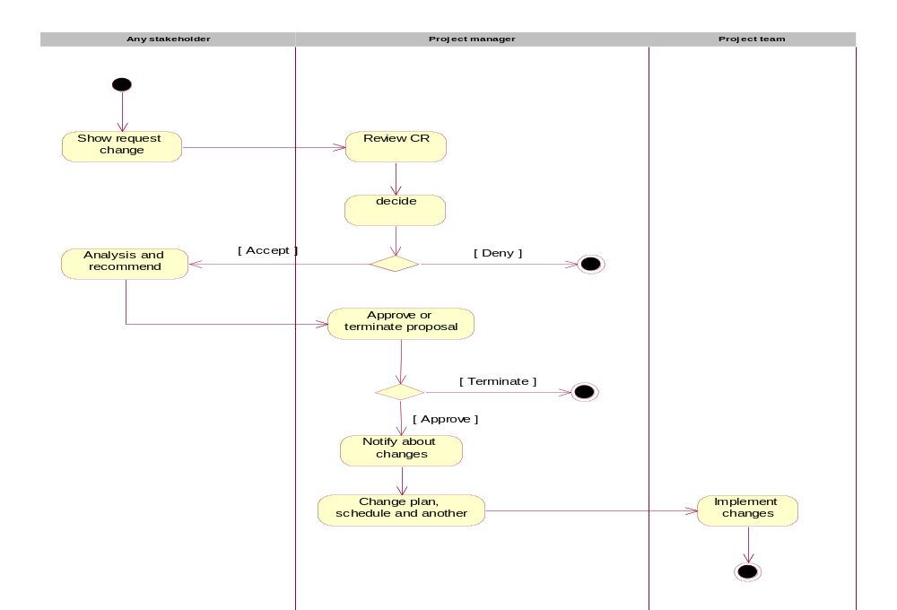

4. Process
The way of change request is handled in project
Change Management Process occur in six steps:
- Display Change Request (CR_ change request) was written.
- Consider the CR and the acceptance or removal for further analysis
- If approved, do the analysis and develop a proposal.
- Accept or removal proposal.
- If approved, update project documents and rescheduled.
- Notify everyone who concerned about the change.
The detailed description of the change management process:
- Any stakeholders may request or determine changes. They use the Change Request Form to write out the nature of the change request
- The completed form is sent to the assigned members of the project team, who import CR on the Project Change Request Log |  | Project Change Request Log
- The CR is reviewed daily by the Project Manager or Change Manager, and assigned one of four results:
- Eliminate | - The notice is sent to the proponent  - The submission may request a review (to the project team)  - The project team reviewed CR in later meetings
- Deferred: | - Project Team is scheduled to review the CR on the a predetermined date  - Inform the proposed  - The submission can not agree and request again  - Project Team review at their CR meeting
- Accept analysis immediately | - Assign a person begins analyzing the impact  - Project Team be notified
- Accept attention by the project team | - Project Team review CR in next week.
- All of the CR is pending to review at project team meetings. The results can be:
- Eliminate: | - Report submitted to the  - Persons may submit objections (to the Project Manager, and possibly to the the monitoring committee)  - A review of the Project Manager is final
- Deferred: | - Project Team is scheduled to review the CR on the some day  - Inform the proposed
- Accept analyzing | - Assign a person begins analyzing the impact  - Inform the proposed
- When analyzing is complete, the project team review the analysis results. The results can be:
- Eliminate: | - Notify the proponent  - People can submit proposals to the Project Manager  - Consideration of the Executive Committee is final
- Accept | - Project Team accept the nomination of the analyzing  - Notify Project Manager as follows:  - CR affects less - Just notice, do not require any action  - CR Impact medium - Project Manager is required review, and no other activities required  - CR influenced - Project Manager approval is required
- Return to analyze more | Project Team has questions or request to be sent back to the analyzing for further consideration
- CR is accepted to be forwarded to the Project Sponsor to review the nominations. The results can be:
- Eliminate | - Notify the proposed  - Persons may submit proposals to the Project Manager  - Consideration of the Project Manager is final
- Accept | - Notify the proposed  - Project Team update the project documents related  - Project Team plans again  - Project Team works on new plan
- Return to analyze more | - Project Manager have questions or suggestions are sent back to the analyzing for further consideration  - Notify the proposed  - The analyzing's recommendation is reviewed by the project team (back to step 5)

- Risk management (wide picture).
Top 10 risks in current project.
No | Risk | Priority | Type
1 | People’s assignments do not match their strengths. | High | Human resource.
2 | Lack member | High | Human resource.
3 | Low effort | High | Human resource.
4 | Lack of skill | High | Human resource.
5 | Limit of knowledge | High | Human resource.
6 | Not meet customer’s requirements. | High | Requirement
7 | Requirement change | High | Requirement
8 | Wrong estimate | Medium | Estimate
9 | Customer communication | Medium | Customer
10 | Customer don’t know what do they want ? | High | Customer

